**4.0 System Analysis and Design – Data Based**

**4.1 Data Modeling**

**4.1.1 Data Dictionary**

1. **User Details**

|  |  |  |  |
| --- | --- | --- | --- |
| **Sr. No** | **Field/s** | **Data Type** | **Constraint/s** |
| 1 | UID | Number | Primary, Auto-Increment |
| 2 | User_Name | Varchar | - |
| 3 | Email | Varchar | Primary |
| 4 | Password | Varchar | Primary |
| 5 | Phone Number | Number | - |
| 6 | Location | Varchar | - |
| 7 | Gender | Text | - |
| 8 | <<display picture>> | - | - |
| 9 | DOB | Date | - |
| 10 | About | Text | - |
| 11 | Is_Admin | Boolean | 0 |

1. **Admin Login**

|  |  |  |  |
| --- | --- | --- | --- |
| **Sr. No.** | **Field/s** | **Data Type** | **Constraint/s** |
| 1 | Admin ID | Varchar | Primary |
| 2 | Password | Varchar | - |

1. **Academic Information**

|  |  |  |  |
| --- | --- | --- | --- |
| **Sr. No.** | **Field/s** | **Data Type** | **Constraint/s** |
| 1 | Institute_ID | Int | Primary, Auto Increment |
| 2 | Institute_Name | Varchar | - |
| 3 | Address | Varchar |  |
| 5 | Contact | Number | - |
| 3 | Email_ID | Varchar |  |
| 3 | About | Text | - |
| 4 | City | Text | - |
| 6 | Stream/s | Text | - |

1. **Chat Backup**

|  |  |  |  |
| --- | --- | --- | --- |
| **Sr. No.** | **Field/s** | **Data Type** | **Constraint/s** |
| 1 | Session_ID | Int | Primary |
| 2 | Time_Stamp | Time | - |
| 3 | ­<<backup file>> | - | - |

1. **Search history**

|  |  |  |  |
| --- | --- | --- | --- |
| **Sr. No.** | **Field/s** | **Data Type** | **Constraint/s** |
| 1 | UID | Int | Primary |
| 2 | Search_ID | Int | Primary, Auto-Increment |
| 3 | Search_Key | Varchar | - |

1. **FAQ**

|  |  |  |  |
| --- | --- | --- | --- |
| **Sr. No.** | **Field/s** | **Data Type** | **Constraint/s** |
| 1 | Question | Varchar | **-** |
| 2 | Answer | Varchar | **-** |
|  |  |  |  |

1. **Feedback**

|  |  |  |  |
| --- | --- | --- | --- |
| **Sr. No.** | **Field/s** | **Data Type** | **Constraint/s** |
| 1 | Feedback_ID | Int | Primary, Auto-Increment |
| 2 | UID | Int | - |
| 3 | User_Name | Varchar | - |
| 4 | Time_Stamp | Time | - |
| 5 | Message | Text | - |

1. **Removed Users**

|  |  |  |  |
| --- | --- | --- | --- |
| **Sr. No.** | **Field/s** | **Data Type** | **Constraint/s** |
| 1 | UID | Number | Primary, Auto-Increment |
| 2 | User_Name | Varchar | - |
| 3 | Email | Varchar | Primary |
| 4 | Password | Varchar | Primary |
| 5 | Phone Number | Number | - |
| 6 | Location | Varchar | - |
| 7 | Gender | Text | - |
| 8 | <<display picture>> | - | - |
| 9 | DOB | Date | - |
| 10 | About | Text | - |
| 11 | Is_Admin | Boolean | 0 |

1. **Settings**

|  |  |  |  |
| --- | --- | --- | --- |
| **Sr. No.** | **Field/s** | **Data Type** | **Constraint/s** |
| 1 |  |  |  |

**4.1.2 E-R Diagram**

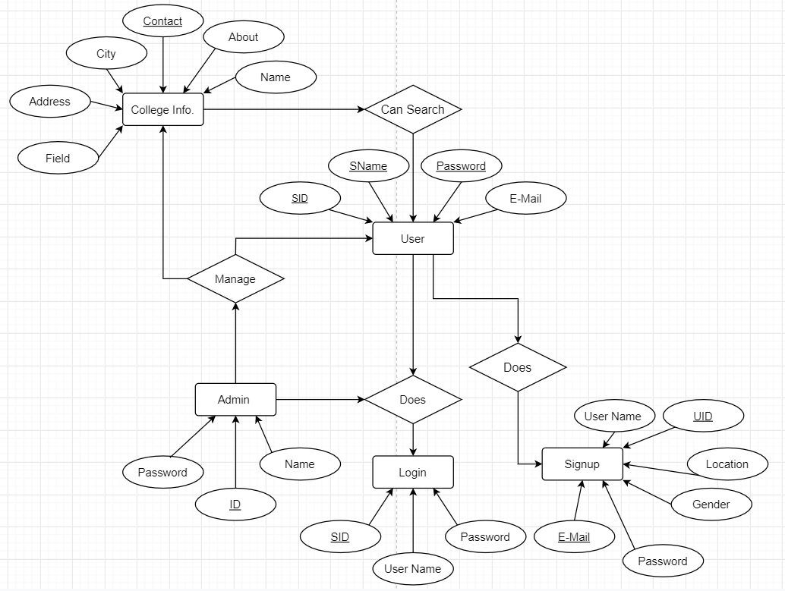

**Fig. ER (Entity Relationship) Diagram**

* 1. **Behavioural Modeling**
     1. **Data Flow Diagram**

A data flow diagram (DFD) is a graphical representation of the “flow of data” through an information system, modelling its process aspects. A DFD is often used as a preliminary step to create an overview of the system without going into great detail, which can later be elaborated. DFDs can also be used for the visualization of data processing (structured design).

* + - 1. **Context Level Diagram (Level 0)**
      2. **DFD – Level 1**
      3. **DFD – Level 2**